**Experiment Title 2.1**

|  |  |
| --- | --- |
| **Student Name: SANSKAR AGRAWAL** | **UID: 20BCS5914** |
| **Branch: CSE** | **Section/Group: 20BCS_MM_806 B** |
| **Semester: 5th** |  |

**Subject Name: Multimedia Technologies Lab Subject Code: 20CSP-339**

**Aim of the practical:** You are given a picture of a garden as background. Extract the image of a butterfly from another picture and organize it on the background using PHOTOPEA.

**Hardware Requirements:**

Minimum 384MB RAM, 100GB hard Disk, processor with 2.1MHz

**Software Requirements:**

Photopea

**Tools Used:**

Type Tool, Magic Wand, Lasso select

Steps for the experiment in photopea:

1. Click on "file" on left upper corner and click new file.

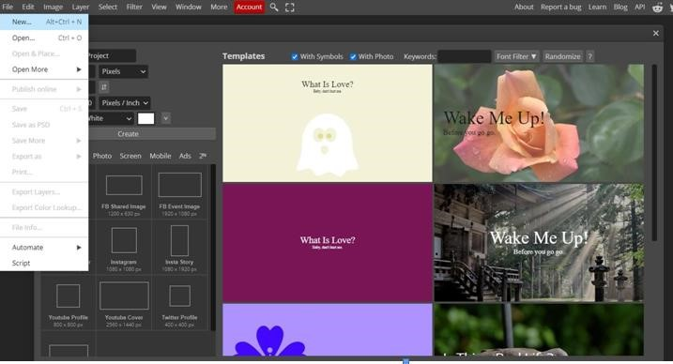

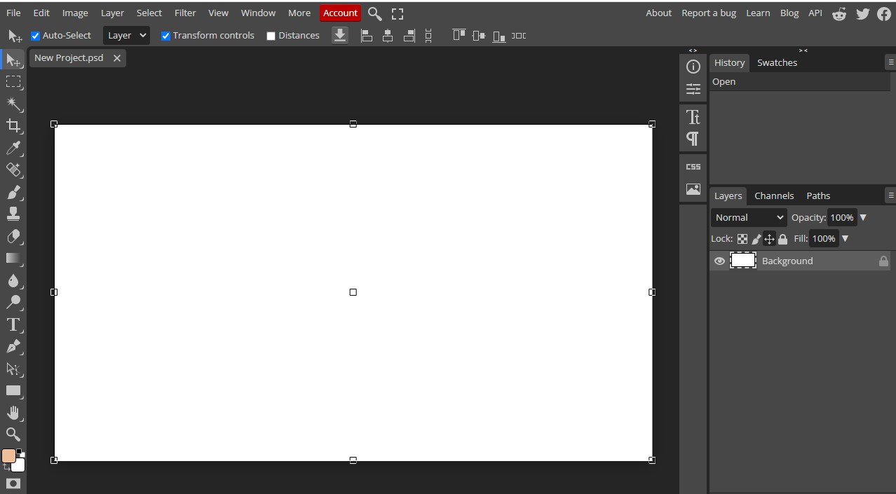

1. Open an image of your choice downloaded from photopea gallery.

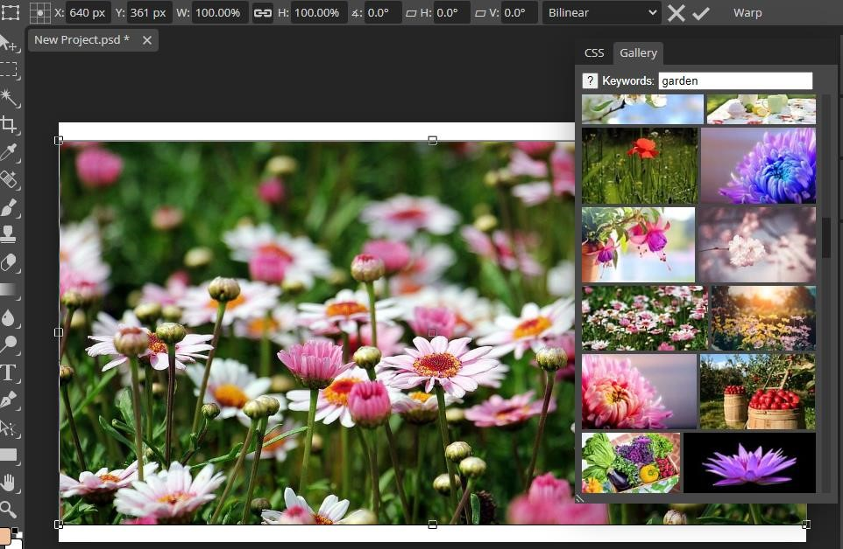

1. Open another file of the butterfly image.

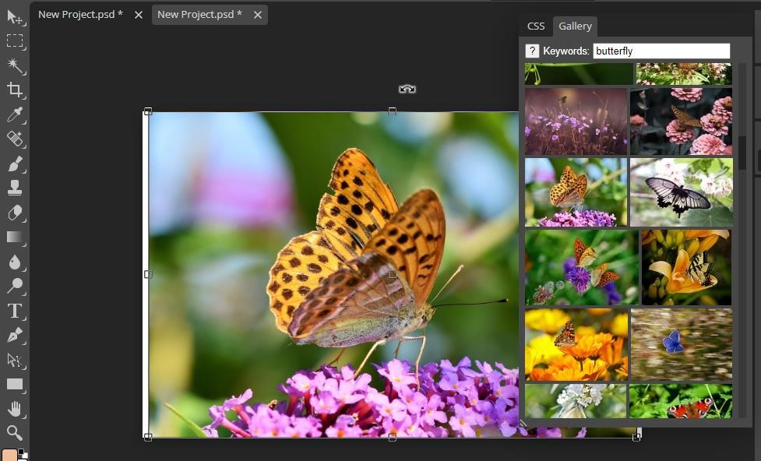

1. Now go to rectangle tool and select the Lasso Select tool.

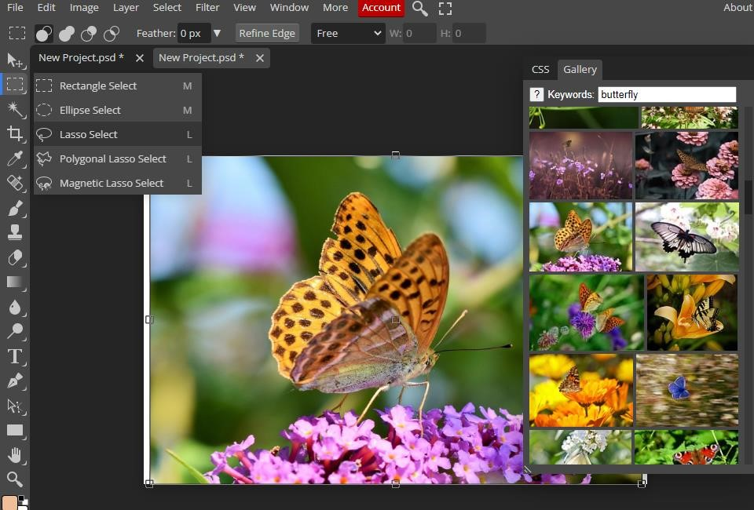

1. Select the outline of the butterfly through the Lasso Select tool.

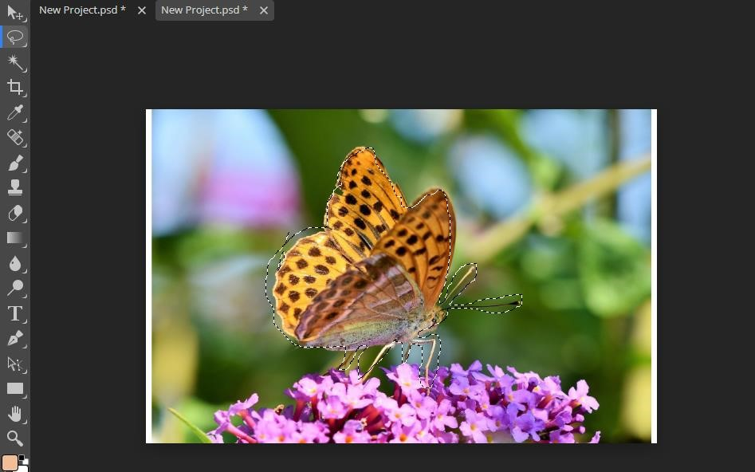

1. If the object is not raterized, do it by going into layers and selecting raterize.

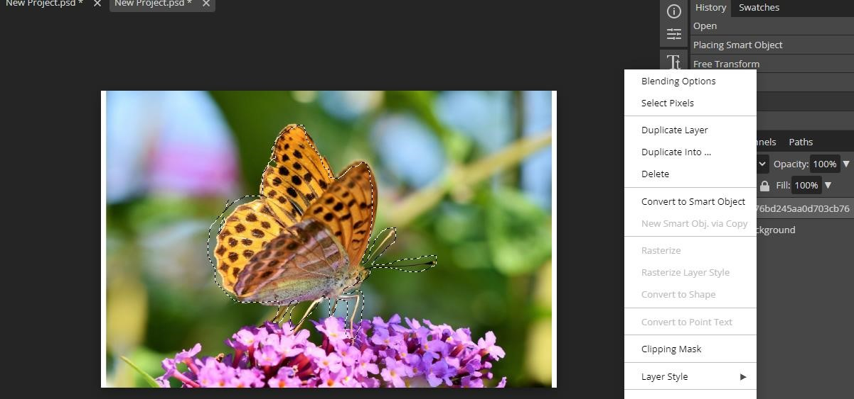

1. Then press Ctrl+X to cut the butterfly from the image.

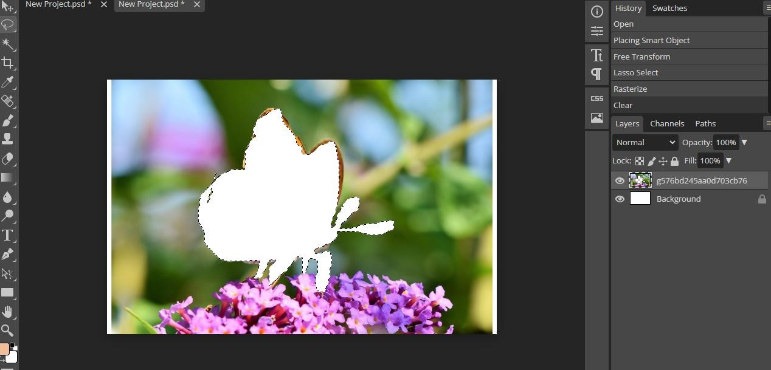

1. Then go into the garden photo and paste the butterfly image.

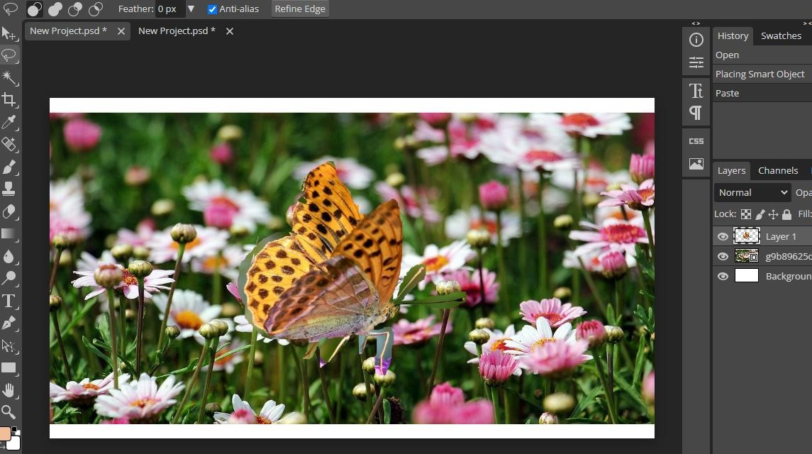

1. Then Select the move tool and tick the transform control to resize/rotate the image as per requirement.

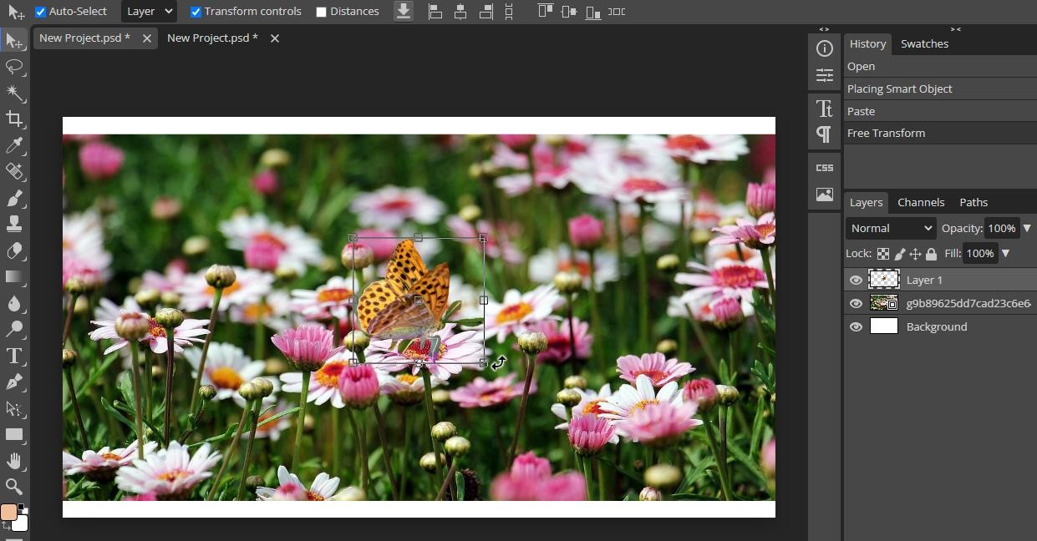

1. 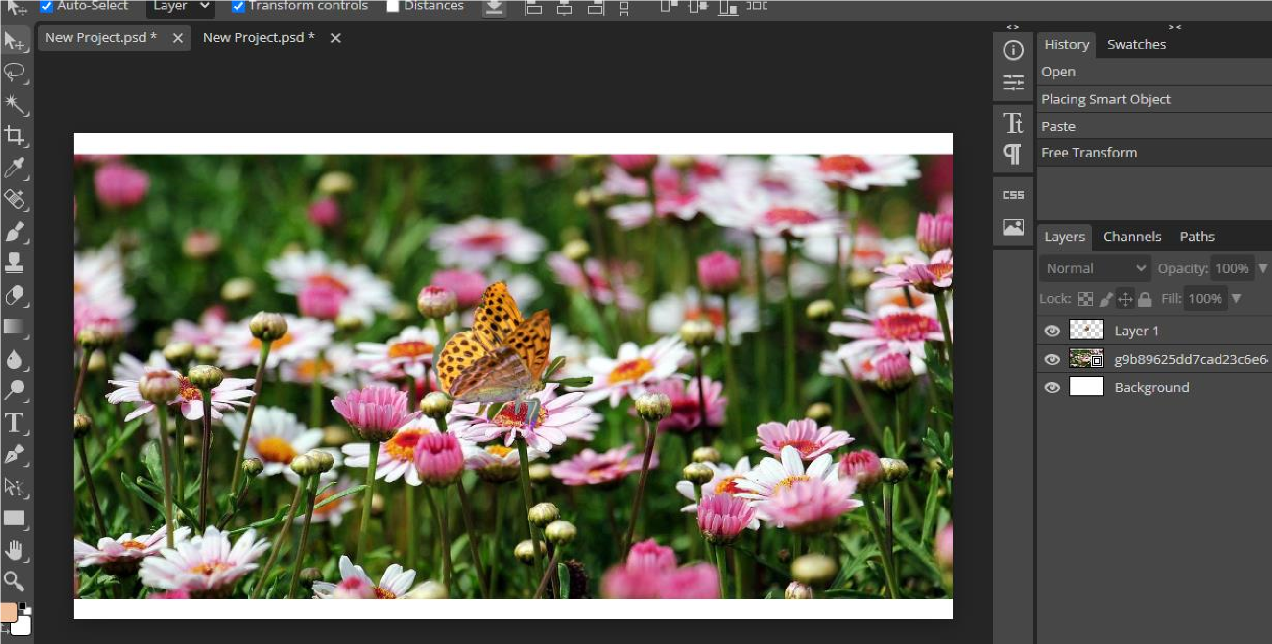The above task is complete.

**Learning Outcomes:**

* Learned about omit an object from a photo.
* how to use lasso select tool efficiently.

**Evaluation Grid (To be created as per the SOP and Assessment guidelines by the faculty):**

|  |  |  |  |
| --- | --- | --- | --- |
| Sr. No. | Parameters | Marks Obtained | Maximum Marks |
| 1. |  |  |  |
| 2. |  |  |  |
| 3. |  |  |  |



|  |  |  |  |
| --- | --- | --- | --- |
|  |  |  |  |